Zhansultanov Ayan
Homework 2
Project 1.

Project 1's code is the simulation of situation when TA is trying to help to 5 students. According to the code each of the students have to receive the help of TA 5 times.

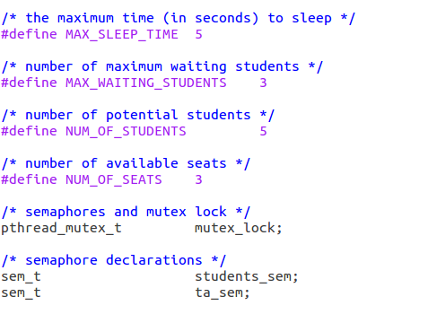

The amount of time which is required to help to each of the students is determined randomly. There are two of semaphores (ta_sem, students_sem) which determines whether TA is free for help or not and if not whether there is a free seat (3 seats) where student can wait. Moreover, if 5th student sees that TA is busy with other student and there is no available seats, he goes hang out for random amount time, and will come again to check for available seat again.

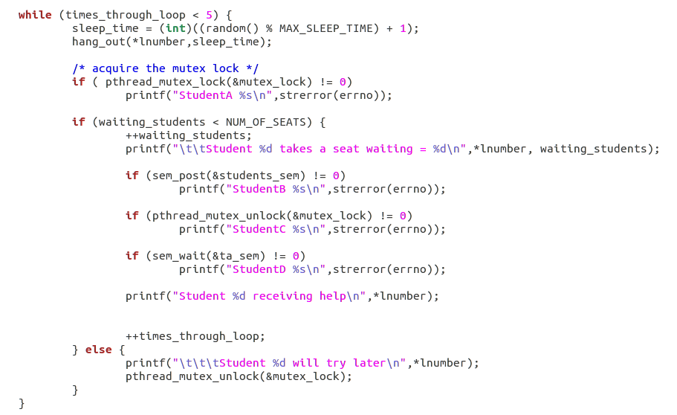

If there is a situation when nobody needs help of TA, Ta starts to sleep (wait). Mutex is used in order to prevent errors.
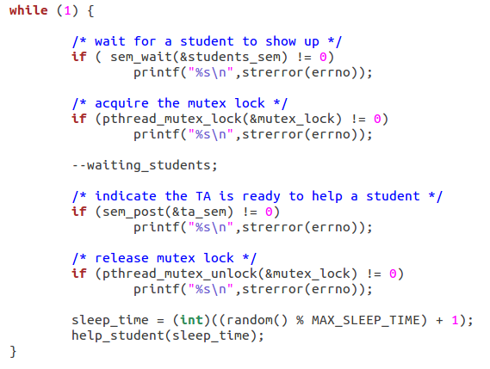

After all students receive help 5 times ta thread will be cancelled.
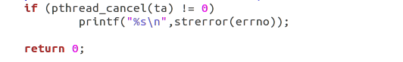
Modification:
1.The ta thread releases the student thread first and only after that prints out “Helping a student for %d seconds”. Consequently, the student thread which just came out of the queue can come to it again while the ta is still helping to this student thread. The Logic is mislead, that is why it is more preferable to realease thread only after the TA's sleep.
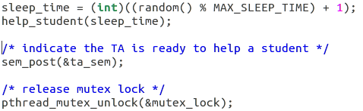

Project 2.
There are 5 philosophers which sit on the circular table, and there are 5 chopstick between each two of them. It is given that one can eat only with 2 chopsticks, so it needs to be monitored how these philosophers should use them, sequentially. In the project forks are used instead of chopsticks, to make code easier.
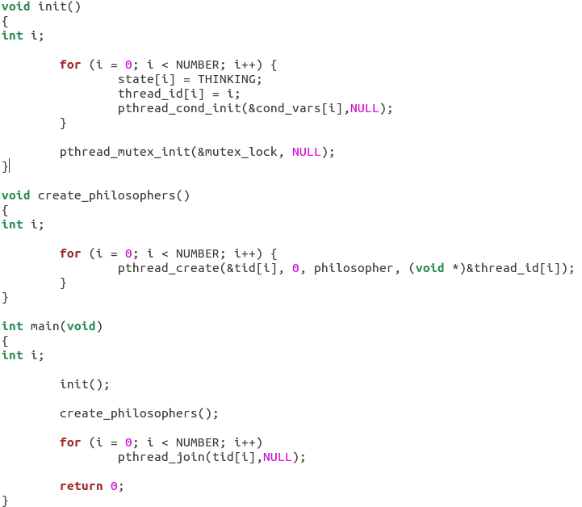

The main function starts from mutex initialization and thread creating, where there are n(NUMBER) number of threads. Each philosopher thread is in form:
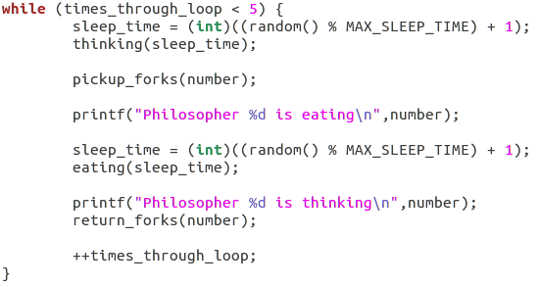

There 5 thread created for each philosopher. And each philosopher needs to eat 5 times (there is while loop, that waits until he eats all 5 times, and only then ends).
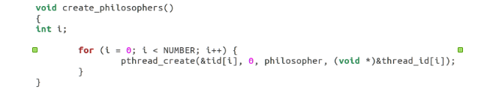

There are 3 states of philosophers. First state is "thinking"- sleeping, second state is "hungry", when they are waiting for their forks. The last state is "eating", when they take their forks and eating for some time.
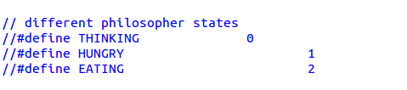

The pickup_forks changes the state of the thread that called it to the HUNGRY state which is value 5. The next step is check is there free fork near the thread:
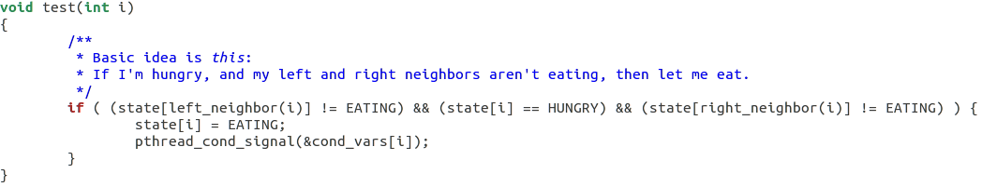
If thread before and after of the calling thread are not eating and caller is hungry then then the state changes to eating and releases the thread that is waiting for the fork.

If the test() doesn't change the state to EATING then it waits to other thread to unlock it.

After the pickup_forks function philosopher thread runs return_forks():
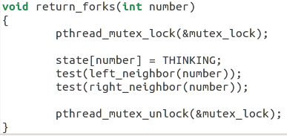

It changes the state to THINKING and if neighbor threads are hungry then one of them can take the fork.

Modifications:
The code is pretty simple, which makes it hard to modify. However I could suggest to substitute such functions like left_neighbor() and right_neighbor() with mathematical approaches. For example, left (j-1)%5 and for right (i+1)%5.
Substitute this:

With this:

if(i=0){
j=6;
}
if(state[j-1]%5] != EATING) && (state[i] == HUNGRY) && (state(i+1)%5] != EATING) ) {
state[i] = EATING;
pthread_cond_signal(&cond_vars[i]);
}

%% Where 5 is predefined in header file variable NUMBER.

Project 3.
Buffer. Consumer- producer problem.
The code takes as an arguments one integer and array of 3 chars. Which I see (modification) redundant because it could take array of integers and there will not be any need for atoi() function. However it wasn't tested due to continues error while compiling buffer.c file.
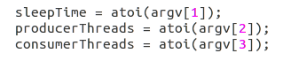

In char array of argument we specify firsly, how much time code will work – sleepTime. Secondly how many producers will be – producerThreads. And thirdly – how many consumer threads will be created – consumerThreads.

After initialization of mutexes and semaphores “for” loops creates the number of threads that were specified:
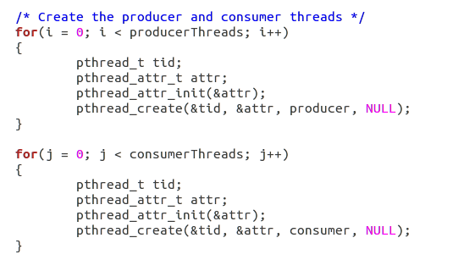

After That threads will be excuted continuesly till sleepTime is not over.
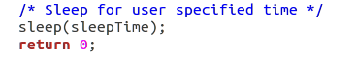

Producer produces item and using insert_item() inserts item in the buffer of capacity of 5. Semaphores regulates the queue so that 6th and forth producers will wait till semaphore “empty” will not allow them to insert their item in the buffer. That happens only when consumer remove the item from the buffer. Allowance for them to remove the item regulates by semaphore “full”. So if there is no consumer to take out the item from the buffer producers will wait and don't do anything. Vice versa, if there is no items in the buffer to consumer to take, consumers will wait till producers produce one. When time is up, code stops executing. The End.

Modification:
As I mentioned before, the only modification which I see possible to make in order to enhance the code is to take integer array as arguments instead of array of chars. So that atoi() functions will not be needed anymore.

4.Monte Carlo with mutex
